#include<iostream>

using namespace std;

struct student

{ char name[20];

unsigned int id;

double score;

void input(student &stu);

void output(student &stu);

};

void student::input(student &stu)

{ cout<<"name?";

cin>>stu.name;

cout<<"id?";

cin>>stu.id;

cout<<"score?";

cin>>stu.score;

}

void student::output(student &stu)

{ cout<<"name:"<<stu.name<<"\tid:"<<stu.id<<"\tscore:"<<stu.score<<endl; }

int main()

{ student a,s={"\0",0,0};

a.input(s);

a.output(s);

}

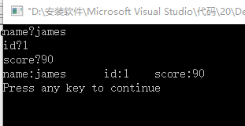

#include<iostream>

#include<string>

using namespace std;

class Book

{ public:

string bookname;

double price;

int number;

void display(Book &name1,Book &name2,Book &name3);

void borrow(Book &number1,Book &number2,Book &number3);

void restore(Book &number1,Book &number2,Book &number3);

};

int main()

{ int i;

Book bn1,bn2,bn3,d;

bn1.bookname="福尔摩斯1";

bn2.bookname="福尔摩斯2";

bn3.bookname="福尔摩斯3";

bn1.price=10;

bn2.price=20;

bn3.price=30;

bn1.number=3;

bn2.number=4;

bn3.number=7;

d.display(bn1,bn2,bn3);

while(1)

{

cout<<"如何你想借书，请输入1，如果你想还书，请输入2"<<endl;

cin>>i;

if(i==1) d.borrow(bn1,bn2,bn3);

else d.restore(bn1,bn2,bn3);

}

cin.get();

cin.get();

cin.get();

cin.get();

cin.get();

}

void Book::display(Book &name1,Book &name2,Book &name3)

{ cout<<"图书情况"<<endl

<<name1.bookname<<":价格为"<<name1.price<<'\t'<<"剩余数量为:"<<name1.number<<endl

<<name2.bookname<<":价格为"<<name2.price<<'\t'<<"剩余数量为:"<<name2.number<<endl

<<name3.bookname<<":价格为"<<name3.price<<'\t'<<"剩余数量为:"<<name3.number<<endl; }

void Book::borrow(Book &number1,Book &number2,Book &number3)

{ Book a;

cout<<"输入你要借的书的名字:"<<endl;

cin>>a.bookname;

if(a.bookname==number1.bookname)

{ number1.number=number1.number-1;

cout<<"借书成功，现在书的数量为:"<<number1.number<<endl;}

if(a.bookname==number2.bookname)

{ number2.number=number2.number-1;

cout<<"借书成功，现在书的数量为:"<<number2.number<<endl;}

if(a.bookname==number3.bookname)

{ number3.number=number3.number-1;

cout<<"借书成功，现在书的数量为:"<<number3.number<<endl;}

}

void Book::restore(Book &number1,Book &number2,Book &number3)

{ Book b;

cout<<"输入你要还的书的名字:"<<endl;

cin>>b.bookname;

if(b.bookname==number1.bookname)

{ number1.number=number1.number+1;

cout<<"还书成功，现在书的数量为:"<<number1.number<<endl;}

if(b.bookname==number2.bookname)

{ number2.number=number2.number+1;

cout<<"还书成功，现在书的数量为:"<<number2.number<<endl;}

if(b.bookname==number3.bookname)

{ number3.number=number3.number+1;

cout<<"还书成功，现在书的数量为:"<<number3.number<<endl;}

}

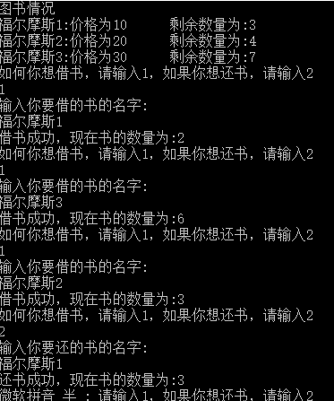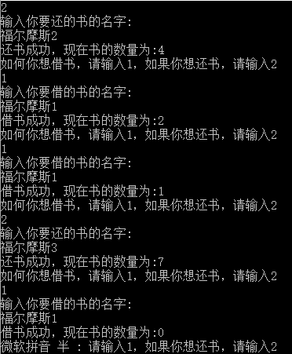

#include<iostream>

using namespace std ;

class student

{ public :

double score;

static double total;

static int count;

void scoretotalcount(double s);

static void sum() { cout<<"总分为:"<<total<<endl; }

static void average() { cout<<"平均分为:"<<(total/count)<<endl; }

int a;

} ;

int student::count=0;

double student::total=0;

int main()

{ int i=0,n;

double t=0;

student bn;

bn.a=0;

while(n)

{ cout<<"请输入学生"<<(i+1)<<"的分数:"<<endl;

cin>>bn.score;

t=bn.score+t;

bn.scoretotalcount(t);

i++;

cout<<"继续请输入1，退出请输入0"<<endl;

cin>>n;

}

}

void student::scoretotalcount(double s)

{ student::total=s;

a++;

student::count=a;

student::sum();

student::average();

}

